PETITION FOR DEGREES Revised 20160824
To the Illustrious Master, Deputy Master, Principal Conductor of the Work and Companions of LAKEWOOD COUNCIL NO. 125, Royal & Select Masons of Ohio:
The undersigned, a Master Mason and Royal Arch Mason in good standing, hereby petitions to receive the three cryptic degrees conferred in your council. Should this petition be granted, he promises to comply with all the forms, usages, laws, rules, orders and regulations of your council and the Grand Council of the State of Ohio.
Enter your legal FULL name. Please DO NOT use initials. Also enter your preferred or common name as you wish it to appear on documents and mailings:

First Name Full Middle Name Last Name Suffix Preferred Name

Street Address City State Zip Code

Home Phone Number Date of Birth Place of Birth Lady’s Name

Cell Phone Number Fax Phone Number Email Address
Occupation & Co. Name:

Business Street Address City, State, Zip Business Tele. No. Bus. Fax Ph. No.
Hobbies & Interests:
Masonic Titles & Honors:
I received the degree of Master Mason on , in Lodge No. under the jurisdiction of the Grand Lodge of . I am presently a member of Lodge No. located in under the jurisdiction of the Grand Lodge of . I received the degree of Royal Arch Mason on _ _, _ _ in _ _ Chapter No. _ _ under the jurisdiction of the Grand Chapter of _ _. I am presently a member of _ _ Chapter No. _ _ located in _ _ under the jurisdiction of the Grand Chapter of _ _.
I have been a resident within the jurisdiction of The Grand Council of Royal & Select Masons of the State of Ohio for the six months last past. I have never before petitioned for these degrees (If you have, state when, what council and action taken):

Dated this day of , Signature:

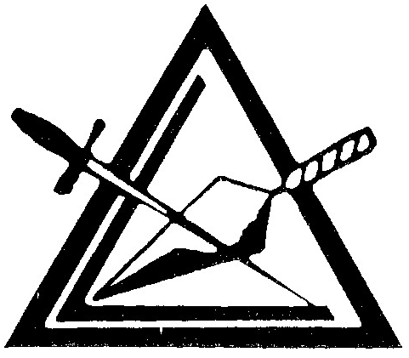
RECOMMENDED BY: INVESTIGATION REPORT:

Lakewood 125
Council No.

Lakewood 125 Favorable Unfavorable
Council No.
Petition and Fees Rec’d: Presented: Balloted: Pass Fail
RM: SM: SEM: _

